Members with 51 Years or More of Membership

If your affiliate, DPG or MIG are interested in honoring those members with 51 years or more of membership with the Academy, this information can be obtained from DMIS.

- Login to DMIS and select the Academy Data tab.

- Select the Export Data link

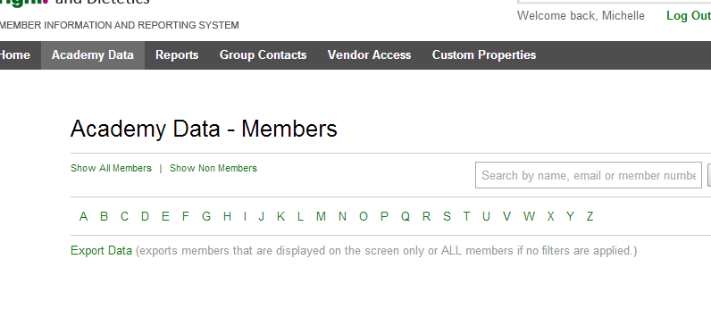

- Make sure the Academy Original Join Date box along with other required fields is checked. Then click the Download Data box.

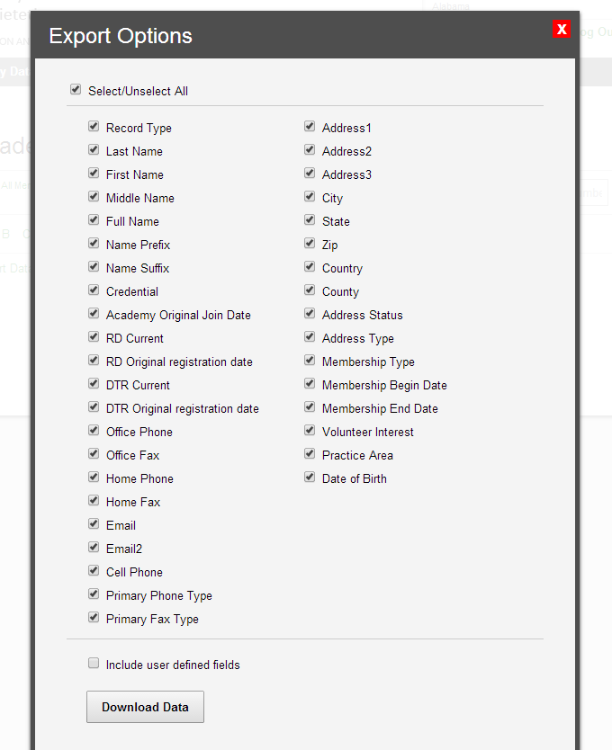

- When the data appears in the Excel spread sheet, highlight the entire spread sheet by clicking the blue arrow.

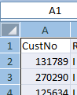

- Select the Data tab and then Sort.

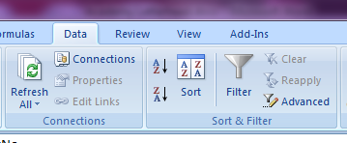

6. Select Add Level and use the drop down to select Member Since in the Sort by field. Then click OK.

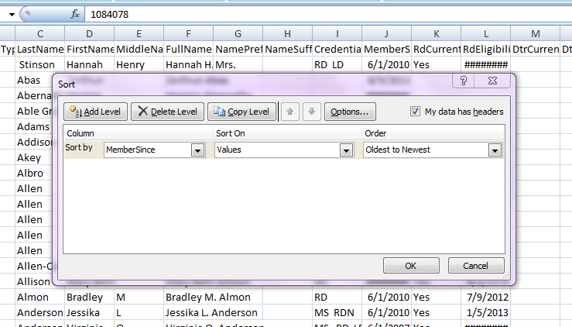
7. Those members who have a Member Since/Original Academy Join Date in 1967 or earlier will be the members with 51 years or more of Academy membership. You can then select those record lines and copy/paste to a new document for further use.

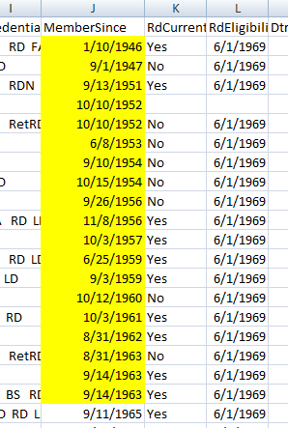

8. If you will be honoring your 51(or more) Year Members at FNCE 2018 run the list again closer to the event so you can have the most current information available at that time.

