The following Academy resources have been identified related to the topics of Cultural Competency, Diversity and Inclusion. All resources are grouped according to the primary segments within the Academy structure to indicate which department, committee, work group or similar is providing the content.
NOTE: I did not list all of the DPG and MIG efforts in these areas as those lists (groups, webinars, etc). If specific inquiry is needed for any group, please let me know and I’ll pull a more focused DPG and MIG list of references for this broad topic area.
DPGs: https://www.eatrightpro.org/membership/academy-groups/dietetic-practice-groups
MIGS: https://www.eatrightpro.org/membership/academy-groups/member-interest-groups

ACEND
Resource | Link
2018 Noteworthy Practice Honorees (note “Curriculum” deliverables) | https://www.eatrightpro.org/acend/public-notices-and-announcements/noteworthy-practices

Journal
Resource | Link
Cultural Competency and Diversity Article Collection (123 Articles in the collection) | https://jandonline.org/content/culturalCompetency
May 2015 Journal Supplement: Think Globally, Practice Locally: Culturally Competent Dietetics | https://jandonline.org/issue/S2212-2672(15)X0002-5

Quality Management
Resource | Link
Practice Tips: Cultural Competence Resources  (note free download link for members; PDF also attached to email) | https://www.eatrightstore.org/product-type/case-studies-and-practice-tips/practice-tips-cultural-competence-resources

Publications
Resource | Link
Cultural Competency for Nutrition Professionals (eBook) | https://www.eatrightstore.org/product-type/ebooks/cultural-competency-for-nutrition-professionals-ebook
Cultural Food Practices | https://www.eatrightstore.org/product-type/books/cultural-food-practices
Pocket Guide to Spanish for the Nutrition Professional | https://www.eatrightstore.org/product-type/ebooks/pocket-guide-to-spanish-for-the-nutrition-professional-third-edition-ebook  https://www.eatrightstore.org/product-type/books/pocket-guide-to-spanish-for-the-nutrition-professional-third-edition
Hispanic Family Nutrition: Complete Counseling Kit | https://www.eatrightstore.org/product-type/ebooks/hispanic-family-nutrition-counseling-kit-ebook
MIDAN Ramadan Toolkit | https://www.eatrightstore.org/product-type/toolkits/midan-ramadan-toolkit-usb-flash-drive--electronic-format
NCM | https://www.eatrightstore.org/product-type/subscriptions/nutrition-care-manual
PNCM | https://www.eatrightstore.org/product-type/subscriptions/pediatric-nutrition-care-manual

Award and Grant Opportunities
Resource | Link
Diversity Mini-Grants for DPGs, MIGs and Affiliates | https://www.eatrightpro.org/leadership/honors-and-awards/diversity-awards-and-grants/diversity-mini-grants
Diversity Leaders Program | https://www.eatrightpro.org/leadership/honors-and-awards/diversity-awards-and-grants/diversity-leaders-program-award
Diversity Promotion Grant | https://www.eatrightpro.org/leadership/honors-and-awards/diversity-awards-and-grants/diversity-promotion-grant
Diversity Action Award | https://www.eatrightpro.org/leadership/honors-and-awards/diversity-awards-and-grants/diversity-action-award
Wimpfheimer-Guggenheim Fund for International Exchange in Nutrition, Dietetics and Management | https://eatrightfoundation.org/why-it-matters/awards/

Continuing Education-Live and Pre-recorded Events
Resource | Link
Nutritional Misconceptions Travel Across the Globe: Different Cultures, Similar Observations | https://www.eatrightstore.org/cpe-opportunities/recorded-webinars/nutritional-misconceptions-travel-across-the-globe
Code of Ethics Review and Update | https://www.eatrightstore.org/cpe-opportunities/recorded-webinars/code-of-ethics-review-and-update
Nutritional Counseling Module 4 - Balancing Mental, Physical and Cultural Influences | https://www.eatrightstore.org/cpe-opportunities/certificates-of-training/nutritional-counseling-module-4
Culinary Nutrition Module 4 - Planning for Healthy Meals and Snacks | https://www.eatrightstore.org/cpe-opportunities/certificates-of-training/culinary-nutrition-module-4
Public Health Nutrition - Module 1: Foundations of Public Health Nutrition | https://www.eatrightstore.org/cpe-opportunities/certificates-of-training/public-health-nutrition-module-1
Sustainable Food Systems Module 2 – From Field to Fork | https://www.eatrightstore.org/cpe-opportunities/certificates-of-training/sustainable-food-systems-module-2

FNCE 2015 - 2018: Diversity and Cultural Competence Track (2015-2016) and additional sessions in 2017-2018 that were cross tracked shown below
All sessions available for on-demand self-study for up to 3 years post meeting.

Access online for 2015-17 at https://www.onlineevent.com/fnce/events which is available free if you attended FNCE for these years below.
Personalized system implemented for 2018 that was sent directly to each attendee for individual access.

2015 Sessions
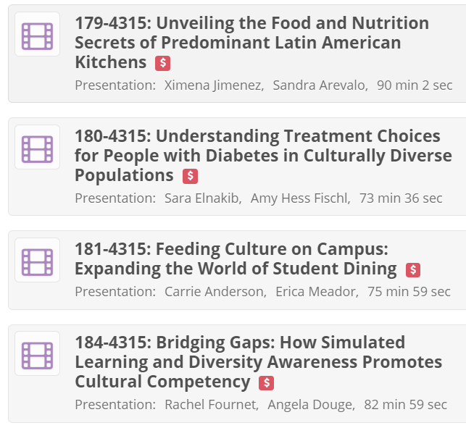

2016 Sessions
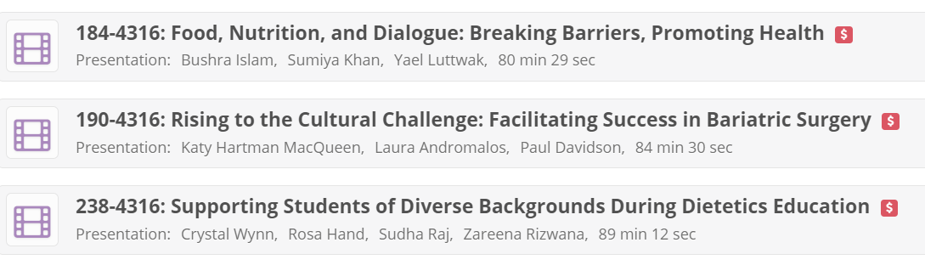
2017 Sessions

2018 Sessions
